Photo 1 – Brother and sister grown up, reaching an aging checkpoint in the brother’s life

Photo 2 – Grandson and grandma at the grandson’s 17th birthday

Photo 3 – Islander communion dinner

Photo 4 – Aging of childhood friends

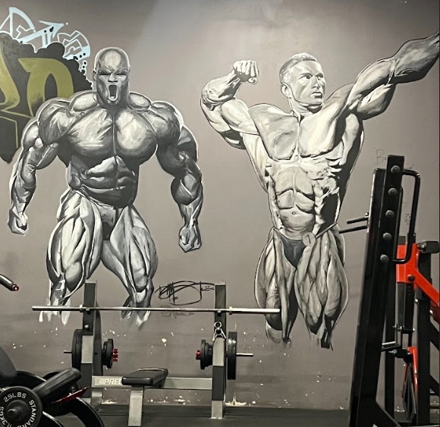

Photo 5 – Legacy of two greats past their prime

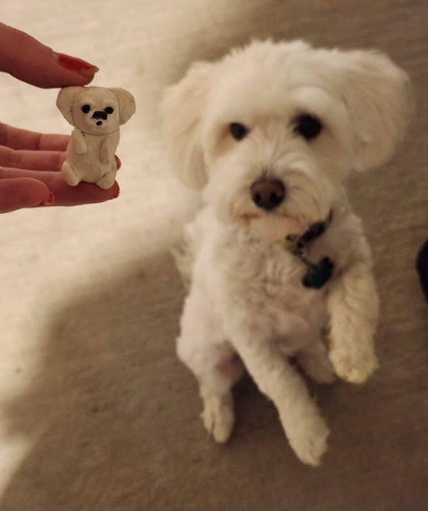

Photo 6 – The changes aging brings to all life

My experience taking these photos over the past two weeks were actually very challenging. It was hard for me to take pictures of things that represent diversity or aging because I feel like I’m always around the same settings that lack both of those things. So, I had to think outside of the box to see how things connected to diversity and aging.

Photo one is a picture I took of my girlfriend with her brother Sau. This was at Sau’s mission farewell party where we had a final get together before his departure to Argentina where he will carry out his 2-year mission for the LDS church. This to me was a huge representation of aging because we had always talked about his upcoming mission in the years prior to him turning 18. 18 is the age at which young men of the LDS church are expected to go and serve a mission so this just marked a milestone in his aging development where I can look back at all his progress from when I met him as a young 13-year-old.

Photo two is a picture I took of my cousin’s 17th birthday celebration while he’s sitting next to our grandmother. This to me represented aging because it showed the vast difference between ages. My grandmother in her old age has developed a lung failure disease while my 17-year-old cousin is in perfect health. This represents the potential health risk that come with aging but is natural in its occurrence.

Photo three is a picture I took of an islander communion dinner I attended with my girlfriend. I took this picture to represent the diversity aspect of this assignment. By inspection of this photo, the individuals in the group look to be of the same cultural and ethnic affiliation but this just shows the danger that a single photo or story can have. These individuals are all pacific islander but of different cultures in their diversity. They are comprised of Fijians, Samoans, and Tongans that have similarities but beautiful difference in every aspect of their lives.

Photo four is a picture that was taken of me and my friends 2 weeks ago at my friend Tylers wedding. I’ve stacked this under a picture of us when we were in the third grade. With 13 years between each picture, I hope to represent the diversity and differences that aging has brought to our group. We all had split ways in the 6th grade to live in different cities, go to different schools, and spend time with different friends. In the end, our aging and development has created fundamental differences in our cultural diversity, but our aging has not affected the bond that we created 13 years ago.

Photo five is a picture that I took of a mural painted on the wall of the gym I go to. When inspecting the photo, it might be hard to understand how this photo represents aging, but to me it shows aging in a timeless way. The individuals in this mural are of bodybuilders who are regarded as some of the greatest of all time. Even in their old age and eventual death, they created an image of themselves for the world to remember them not in their immaculate maturity, but in their dominant prime.

Photo six is a picture I took of my friend’s dog next to a clay sculpture of their dog. This represents the aging that all forms of life go through. When I first met their dog, it was when they first adopted him as a baby. Though he was not as small as the sculpture in the picture, I remember him being about the size of my hand. Now that he is the size of my arm, I can’t help but look back and remember how small he was and how much he has aged into the being he his today. Aging is not a thing limited to humans on this planet but everything on this planet. Animate and inanimate objects all age and go through their respective cycles of life.